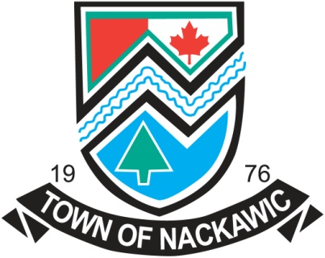

NACKAWIC FORESTRY CAPITAL OF CANADA 1991
SCHOLARSHIP FUND
The Forestry Scholarship Fund was founded by the Forestry Capital of Canada Committee during Nackawic’s tenure as Forestry Capital of Canada in 1991.
Recognizing the role of education in perpetuating Canada’s Great Forests, the Committee raised the money for this legacy during the organizing and implementation of many events structured to commemorate our forests and forestry industry. On completion, this fund was donated to the Town of Nackawic to assist in the education of a Nackawic Senior High School student intent in furthering their career at a community college, forestry school, or university of his or her choice. The student must be accepted in a program of the environmental sciences, i.e. biology, chemistry, engineering or other related disciplines at a community college, forestry school, or university of his or her choice. The fund is now administered by the Council of the Town of Nackawic.
Please write a brief essay relating your career to the forest industry.
Interested students will apply by completing the questionnaire on the reverse side of this sheet and by mailing or delivering same to the Town Hall no later than May 31st, 2018.
The Town will announce the name of the successful applicant each year during the Nackawic Senior High School Graduating Ceremonies. This is a one-year scholarship and cheques will be made payable to the educational institution in which the student is enrolled.

Application Form

_____________________________________________________________________________________
Surname Given Names Initials
Mailing Address: _______________________________________________________________________
Street Address: _______________________________________________________________________
Phone Number: _______________________________________________________________________
College or University you plan to attend: ___________________________________________________
Name of course enrolled in: _____________________________________________________________
Other scholarships received: _____________________________________________________________
How will your training affect, improve, accentuate or benefit our forests? (Attach additional sheets, if required)
_____________________________________________________________________________________________________________________________________________________________________________________________________________________________________________________________________________________________________________________________________________________________________________________________________________________________________________________________________________________________________________________________________________________________________________________________________________________________________________________________________________________________________________________________________________________________________________________________
Applicant’s signature: _________________________ Date: __________________
To be received no later than May 31st, 2018
Mail to: Town of Nackawic
115 Otis Drive
Nackawic, NB
E6G 2P1

